Workshop on the restoration of the CMS FW RPC system

CERN June 25th and 26th 2007

Participants: T.Virdee (CERN/ Imperial College) CMS spokesperson
G.Tonelli (CERN/ INFN Pisa) Deputy CMS Spokesperson
A.Ball (CERN) CMS Technical Coordinator
G.Iaselli (Bari University) RPC Project Manager
W.Van Doninck (CERN/ IIHE Brussels) FW RPC coordinator
A.Sharma (CERN)
Y.Ban (Peking University China)
C.Jiang (IHEP Beijing China)
A.Gurtu (TIFR-EHEP India)
M.Tytgat (University of Ghent Belgium)
E.Daubie (University of Mons Belgium)
L.Van Lancker (IIHE Brussels Belgium)
J.T.Rhee (Konkuk University Seoul Korea)
K.S.Lee (Korea University Seoul Korea)
S.Park (Korea University Seoul Korea)
I.Crotty (CERN/ University of Wisconsin)
T.Tuuva (University of Lappeeranta and Helsinki Finland)
M.Kudla (University of Warsaw Poland)

Connected: S.Qian (Peking University China)
W.Smith (University of Wisconsin) CMS Trigger Project Manager
F.Loddo (Bari University Italy)

Agenda and Slides @:

http://indico.cern.ch/conferenceDisplay.py?confId=17889

Monday 25 June 2007
09:00 Welcome, Introduction and Goals (15') Tejinder Virdee
09:20 Timescale and schedule (15') Austin Ball
09:45 Technical Issues (20') Giuseppe Iaselli
10:15 Project and Options (30') Walter Van Doninck

11:00 Coffee break

11:20 Gas gap production (20') Sung-Keun Park
12:00 Production of the YE4 shielding wall (20') Austin Ball
12:30 Prospects for low eta chambers (20')
Tuesday 26 June 2007
09:00 On-detector Electronics (20') Flavio Loddo
09:30 Trigger requirements and prospects (20') W. Smith
10:00 Off Detector Electronics and Services (20')

10:30 Coffee break

10:50 Presentation/possibilities of the groups (1h00') All
11:50 Round table discussion (1h00') All
13:00 End of workshop

Resume:

The CMS spokesperson, T.Virdee, welcomed the participants and explained the aim of this workshop (see slides @ indico). In particular he showed the table that was shown at the RRB and included in the document CERN-RRB-2006-105.

Since the initial discussions with some of the funding agencies, the University of Ghent (Belgium) has officially joined CMS during the last CMS week with emphasis on the RE restoration project. The other Belgian groups have expressed their interest to devote the CTC phase 3 budget to this system and some of them would join as participants. The participation of Italy to this project would be highly appreciated but is subject to discussions with INFN. The possibility whether a CERN group could join this project is also under investigation.

G.Iaselli gave an overview of the technical issues involved:

- Bakelite procurement in Italy has been a long standing R&D effort to arrive at adequate QA/QC procedures to ensure a suitable material for RPC operation. The fear that the key person at the Bakelite production plant would disappear is no longer justified and procurement of the same quality Bakelite should remain possible for a few more years. This is considered as baseline for the restoration.
- Production of gas gaps can proceed either in the GT company in Italy (CMS barrel gaps) and at the Korea University in Seoul (CMS end cap gaps). It is considered inadequate to set up yet another gas gap production plant. It is therefore crucial that the Korean facility remains operational.
- For the Front end electronics developed and built in Italy some VLSI chips are still available (order of 5000). But the AND/OR on detector logic required in some options needs to be developed. This issue will be addressed in F.Loddo’s talk.
- For the high eta region (1.6<η<2.1) we should keep 10³⁴ as a target and not SLHC since this high eta region may be condemned at SLHC as pointed out by A.Ball. The initial plan to install order of 6 RE1/1 chambers remains of high interest and priority in order to learn about the experimental environment in this region and the performance of RPC’s there. In this respect Korea will make an effort to produce these 10 degree RE1/1 chambers for installation in CMS prior to the lowering of YE-1. R&D on alternative detectors for high rate operation in the high eta region is not considered at this stage.
- The new and old groups involved in this project should not embark on the production right away. The commissioning and operation of the already existing RPC system of CMS should be tackled by all groups as a common effort in a single project (barrel + end caps). It is the ideal occasion for the newcomers to get the necessary training and expertise required for the completion of the system. In this respect the University of Ghent envisages to send 3 Ph.D. students to CERN during this summer to participate in the commissioning effort.
- For this restoration project it is considered important that the GIF facility and the ISR laboratory with its cosmic stand remain operational or are eventually restored in maybe another location.

A.Ball pointed out that the natural period for the deployment of the restored items would be the long winter shutdown 2009-2010. Maybe also the next shutdown would be required to finalize the installation. The 2008-2009 shutdown is expected to be short (~ 3months) and many other requests for access may preclude RPC installation in that period. The YE4 shielding walls, on which the RE4 station is possibly to be mounted, is not in the scope of the present project. Its cost estimate is ~ 1.65 MCHF of which only part is possibly covered by Pakistan. CMS TC is investigating the possibility to substitute these 10mm thick steel disks by a steel casing filled with scrap at much lower cost. Also the possibility to mount RE4 off the YE3 disks behind the CSC’s could be considered and would ease the services to that RPC station.

W.Van Doninck showed the present status of the RE system with 5 out of the 6 initial RPC layers installed and pre-commissioned. 3 Options were presented for the restoration:
- Increase the geometrical coverage to the TDR layout with 4 stations but keeping 1 HV channel for 2 chambers.
- Restore the full TDR system with 1 HV channel per chamber.
- The improved TDR system with 5 stations and full geometrical acceptance. For this latter option, a new double layer station 2 (the trigger seed station) would have to be build and the present station 2 moved to become RE4. To avoid shimming the magnet yoke and the “inflation” of the required link system it is proposed to make an on detector AND/OR in this new station 2 ensuring “clean” seeds to start the trigger trajectories.

The costing of these options is shown in the excel sheet without the necessary common fund for the project which would be a “pedestal” to add to all options.

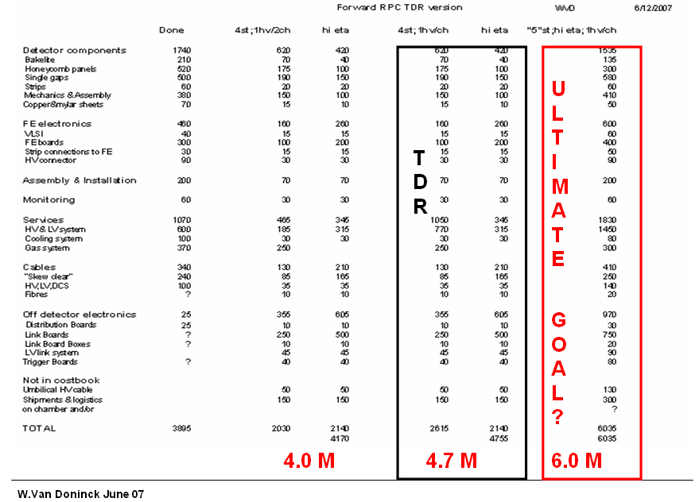

In the possible timeline shown, the project should be defined and finalized wrt. engineering design and integration by the end of 2007. Gas gap production is expected to resume in spring 2008 followed by chamber assembly and testing. Installation of the initial part of the restoration could then happen in the 2009-2010 shut down. Clearly only the third option still requires design and integration.

S.Park reported on the search for Bakelite from local vendors, an activity in the shadow of the baseline which remains purchase from Italy. Gap production for the present RPC system is completed, but the plant is kept operational. A crew of about 5 persons is required to operate the gas gap production facility. In the initial MOU, Korea has expressed interest in the high eta part of the system. With highest priority they want to produce about six 10 degree RE1/1 chambers to be installed in the “nose” of the YE-1 end cap. It was emphasized that this deployment should happen while YE-1 is still on the surface. The financial situation in Korea is still unclear and no budget is at present available for this high priority small project ; help from other institutions may be required. It was felt that Korea should deal with the gas gaps and the mechanics for these 6 small RPC’s and some help could possibly be found to procure the front end boards. On the long term their interest remains with the high eta part of the system.

F.Loddo presented three possibilities for the front end:

- Use the existing FE chips in BiCMOS technology that is 10 years old but of which some 5000 are still at hand. Also the technology is still available and has been qualified for the TDR system (NIM.A 484 (2002) 494-509). A new foundary run would require a minimum purchase of 5000 chips. The latter could be envisaged for the high eta part hence ensuring margin on the radiation tolerance. A new extra board should then be produced to perform the on detector AND/OR logic.
- Develop a new FE board on which the AND/OR is embedded.
- Develop a new FE chip including the AND/OR logic.
Certainly the remaining components are adequate and could be used for the low eta part of the restoration project.

W.Smith reviewed the trigger requirements and prospects. He emphasized the important gain in robustness of the 1st level muon trigger when a 5th station is added wrt. the TDR 4 station system.
The 4 station loose trigger (3 out of 4) presents too much rate at 10³⁴ luminosity while the tight trigger (4 out of 4) suffers from a significantly reduced efficiency. Wesley’s recommendation for restoration puts the highest priority on the 5 station low eta part of the project.
The absence of high eta coverage with RPC’s forces the 1st level muon trigger to be provided by a 3 station CSC system which, as compared to 2 CSC + RPC confirmation, suffers a penalty of 30% in efficiency in the 1.6<η<2.1 region. In this high eta region, the RPC stations 1 and 2 are most important since most of the magnetic bending is concentrated there.
It was realized that the simulations used for the evaluation of the trigger performance were quite old and some effort should be found to update them.

M.Kudla showed the implications for the Trigger and Link systems to cope with the extra RPC’s. For the trigger part 24 extra Trigger boards need to be produced and extra cables laid from USC to UXC. All other items (DCC, CCS, crates etc.) are available to handle the restored system. For the Link part RE1/1 requires 72 MLB and 12 Control boards of a special design and shape to fit the LBB’s installed on the end cap nose. For all other extra RPC’s some 144 MLB, 192 SLB, 24 CB and 12 LBB’s are required. The costs are well understood and included it the costing of the restoration project.
A.Gurtu reported on the RPC assembly that has started in India for ~ 12 RE*/2 type chambers. Some confusion on ways of payments and procurement of gas gaps from Korea has been mentioned but completion of these detectors by fall 2007 seems reasonable.

Groups expressions of interest:

Italy: Negotiations with INFN have not yet started and hence it is too early to make precise statements. With their experience on the barrel system and the large contributions to the forward system in terms of Bakelite procurement and front end electronics, they are of course interested and would be a great asset to this completion of the CMS RPC system. From commissioning onwards and certainly during the operations phase, the RPC system in CMS should be considered as one, with crews from all communities working together. The main emphasis of the Italian groups at present is to get the as yet built system to operate correctly.
Finland: Only small amounts of funding can be envisaged, but the expertise in designing and building Link Boards will be assured.
Poland: Similar as for Finland. They could handle the extra trigger boards but would require funding for the expansion of the Link system. Expertise will be assured.
Korea: Ready to continue producing gas gaps if proper funding is eventually granted and made available. They maintain interest in the high eta part of the system and envisage assembling part of those detectors in Seoul. It is understood that they will do their best to provide 6 RE1/1 RPC’s for start up.
India: Interest was expressed for one low eta layer of RPC’s on one end cap, for example RE2bis. A budget request of 0.8 MCHF is with their funding agency. India would like to see the ventilation of expenses done to cover the layer they will eventually build. Some temporary funding is available and they have started to assemble 10-12
detectors of the RE*/2 type.
China: Interest was expressed for the high eta chambers with emphasis on RE1/1. Funding for now is not available but a request of about 0.5 MCHF would be made to the funding agency.
Belgium: Since the University of Ghent has recently joined CMS, we have 3 Flemish and 3 Walloon groups as CMS members. The Belgian groups have agreed on the principle to invest their contribution to CTC phase III to this restoration project
(420 kCHF). However not all groups will contribute to the construction and operation of this RPC system since their main activity in CMS concerns the Tracker. The groups hope to increase their request for funding to about 1 MCHF for this restoration project.
Pakistan: No representative attended the workshop. In the minimal forward system that we have at startup, Pakistan has been a key player since they assembled and installed 4 out of the 6 RPC layers presently part of CMS. They purchased all the Front End Boards and the power system (HV, LV) for the forward RPC’s. Since long they have expressed interest in taking care of station RE4 which initially was part of their scope. Already some time ago they earmarked 1.25 MCHF to this completion. Also some funding is foreseen in Pakistan for the YE4 shielding walls (~0.8 MCHF) which could be sufficient for one end cap.
Iran: This country has expressed interest in participating to the forward RPC project in CMS and had a representative at the ISR during RE1 assembly. A possible contribution to the YE4 shielding walls has also been considered. They hope to contribute order of
0.8 MCHF to the project.
CERN: So far CERN is not an official member of the RPC project despites the fact that they have contributed far more than host lab obligations to this system. The CMS common fund “loan” of 0.8 MCHF, the ISR assembly lab, the handling of shipments and logistics in the system and the substantial support of manpower at CERN are only a few examples. It is therefore considered that it would be of great asset to the CMS RPC system if a CERN based group would officially join for this restoration project. The disappearance of CERN help to this project would certainly endanger a successful completion of this muon system. A modest budget could then also be envisaged but certainly not as substantial as the help provided so far. Order 1 MCHF could possibly be considered.

During the following round table discussion the following road map, in 3 phases, has been adopted and considered as baseline:

Phase I: (for installation during 09-10 shut down)
Completion of the low eta part i.e. RE4/2, RE4/3, RE2/2bis, RE2/3bis. In the scenario presented by Walter, RE4 would be the present RE2 and a new double station RE2+RE2bis would be built. The HV remains at 1 channel for 2 chambers.

Phase II: (for installation during the 10-11 shut down)
Completion of the entire high eta part, bringing RPC coverage up to the one presented in the TDR i.e. η=2.1. This will require RE1/1 (72 chambers of 10 degrees), RE2/1 (36 double chambers of 20 degrees), RE3/1 (36 chambers of 20 degrees) and possibly RE4/1 (36 chambers of 20 degrees).

Phase III: (can be installed at any time)
Restoring the HV system, i.e. cover 1 RPC chamber with 1 HV channel.

A more detailed costing of the 3 phases is shown in the Excel sheet below to which the provision of a common fund of 1.5 MCHF needs to be added.

It was also remarked that the trigger performance studies are somewhat outdated and it would be appropriate to update them with the layouts considered now and the known chamber performances (in terms of singles rates). Several groups have expressed interest in taking up this point.

The workshop ended on Tuesday around 13:00.

WVD 3/7/2007
